2013 National Radon Poster Contest

Certificate of Participation

Kansas State University and
The U.S. Environmental Protection Agency,
recognize and thank
Student’s Name Here
for helping to educate the public on the issue of radon through the poster
“Title of Poster Here”

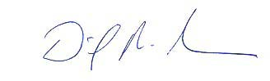

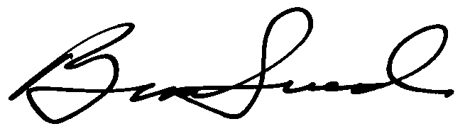
David P. Rowson Bruce Snead
Director, Indoor Environments Division Administrator, National Radon Program Services
U.S. Environmental Protection Agency Kansas State University

